

HITEC UNIVERCITY TEXILA CANTT
BS-CyS-CYBER SECURITY
ARTIFICIAL INTELLIGENCE
PROJECT REPORT
TITLE: Stroke Prediction Using Machine Learning with Class Imbalance Handling

NAME & REGISTRATION NO:
MUHAMMAD AMEER KHAN (24-Cys-062)
SAIFAL ASHIQ (24-CyS-064)
SUBMITTED TO:
SIR MUBASHIR IQBAL

BS CYBER SECURITY PROGRAM
DEPARTMENT OF COMPUTER SCIENCE HITEC UNIVERSITY, TAXILA
Table of Contents
TITLE OF ARTICLE 4
ABSTRACT 5
INTRODUCTION 6
Paragraph 1: Broad Domain Context 6
Paragraph 2: Narrow Topic Focus 6
Paragraph 3: Research Gap and Motivation 6
Paragraph 4: Why This Problem Now 6
Paragraph 5: Our Contribution 6
Paragraph 6: Paper Roadmap 6
LITERATURE REVIEW / RELATED WORK 7
Overview 7
Traditional Machine Learning Approaches 7
Ensemble Learning Methods 7
Data-Centric Challenges 7
Research Gap 7
PROPOSED RESEARCH METHODOLOGY 7
Dataset Description 7
Preprocessing Steps 7
Exploratory Data Analysis (EDA) 8
9
Class Balancing 9
Normalization 9
Train-Test Split 9
Framework Diagram Steps 9
ALGORITHMS USED 9
Logistic Regression 9
Random Forest 10
EXPERIMENTAL SETUP 10
Dataset Description 10
Dataset Link 10
Hardware Configuration 10
Software Environment 10
Hyperparameter Configuration 11
PERFORMANCE EVALUATION METRICS 11
12
12
12
RESULTS AND DISCUSSION 13
13
14
CONCLUSION 15

Figure 1:Age Distribution Comparison Between Stroke and Non-Stroke Patients 8
Figure 2:Distribution of Stroke and Non-Stroke Cases in the Dataset 8
Figure 3:BMI Distribution for Stroke and Non-Stroke Cases 9
Figure 4:Correlation Heatmap of Healthcare Features 12
Figure 5:ROC Curve for Random Forest Model 12
Figure 6:Confusion Matrix of Random Forest Classifier 13
Figure 7:Confusion Matrix of Logistic Regression Model 14
Figure 8:ROC Curve for Logistic Regression Model 14

TITLE OF ARTICLE
Stroke Prediction Using Machine Learning with Class Imbalance Handling

ABSTRACT
Early detection of stroke is a critical challenge in the healthcare domain due to its sudden onset and high mortality rate. Stroke is one of the leading causes of death and long-term disability worldwide, and timely prediction can significantly improve patient outcomes. However, existing predictive systems often suffer from limitations such as class imbalance, missing medical data, and insufficient evaluation of model performance.
In this project, we propose a machine learning–based stroke prediction system using structured healthcare data. The proposed methodology involves extensive data preprocessing, including handling missing values, encoding categorical variables, feature scaling, and addressing class imbalance using the Synthetic Minority Over-sampling Technique (SMOTE). Exploratory Data Analysis (EDA) is performed to understand feature relationships and stroke distribution. Two supervised machine learning models—Logistic Regression and Random Forest—are trained and evaluated for binary classification.
Experimental results demonstrate that the Random Forest model outperforms Logistic Regression in terms of accuracy, precision, recall, and F1-score. ROC-AUC analysis further confirms the robustness of the proposed approach. The developed system provides an effective decision-support tool for early stroke risk assessment and can assist healthcare professionals in preventive diagnosis.

INTRODUCTION

Paragraph 1: Broad Domain Context
Artificial Intelligence (AI) and Machine Learning (ML) have become integral components of modern healthcare systems, enabling data-driven decision-making and predictive analytics. With the increasing availability of electronic health records and medical datasets, ML techniques are widely used for disease diagnosis, prognosis, and risk prediction. AI-based healthcare solutions improve accuracy, reduce human error, and support clinicians in managing large-scale patient data efficiently.

Paragraph 2: Narrow Topic Focus
Stroke is a serious medical condition that occurs when blood flow to the brain is interrupted, leading to brain damage or death. According to global health statistics, stroke remains one of the leading causes of mortality and long-term disability. Early identification of individuals at high risk of stroke can help initiate preventive treatment and lifestyle changes, thereby reducing fatal outcomes.

Paragraph 3: Research Gap and Motivation
Despite the availability of several ML-based stroke prediction models, many existing approaches suffer from significant drawbacks. Most healthcare datasets are highly imbalanced, with far fewer stroke cases compared to non-stroke cases, which leads to biased model performance. Additionally, missing values and categorical medical features are often poorly handled. These issues reduce the reliability of traditional prediction systems.

Paragraph 4: Why This Problem Now
Recent advancements in ML algorithms, data preprocessing techniques, and imbalance-handling methods such as SMOTE have made it possible to address these challenges more effectively. With improved computational resources and open-access healthcare datasets, it is now feasible to develop accurate and interpretable stroke prediction models.

Paragraph 5: Our Contribution
In this research, we develop a robust stroke prediction system using machine learning. The healthcare stroke dataset is preprocessed by handling missing BMI values, encoding categorical variables, and normalizing numerical features. Class imbalance is addressed using SMOTE. Logistic Regression and Random Forest models are trained and evaluated using multiple performance metrics, including ROC-AUC and confusion matrices.

Paragraph 6: Paper Roadmap
The remainder of this report is organized as follows: Section 2 reviews related work, Section 3 explains the proposed methodology, Section 4 describes the experimental setup, Section 5 discusses performance evaluation metrics, Section 6 presents results and discussion, and Section 7 concludes the study.

LITERATURE REVIEW / RELATED WORK

Overview
Existing stroke prediction research primarily relies on machine learning techniques applied to structured healthcare data. Three major approaches dominate the literature: traditional machine learning algorithms, ensemble-based methods, and data-centric preprocessing techniques.

Traditional Machine Learning Approaches
Several studies have employed Logistic Regression, Support Vector Machines (SVM), and K-Nearest Neighbors (KNN) for stroke prediction. Logistic Regression is widely used due to its interpretability, while SVM performs well in high-dimensional spaces. However, these models often struggle with imbalanced datasets and fail to capture complex feature interactions.

Ensemble Learning Methods
Ensemble techniques such as Random Forest and Gradient Boosting have shown improved performance in medical diagnosis tasks. Random Forest reduces overfitting by combining multiple decision trees and can handle both numerical and categorical features effectively. However, many studies neglect proper class balancing, leading to biased predictions.

Data-Centric Challenges
Healthcare datasets commonly contain missing values, noisy data, and severe class imbalance. Studies that ignore these challenges report high accuracy but poor recall for minority classes. Techniques such as SMOTE have been proposed to overcome imbalance, but their application in stroke prediction remains limited.

Research Gap
Most existing works focus either on model accuracy or preprocessing, but not both simultaneously. There is a lack of comprehensive pipelines that integrate preprocessing, balancing, normalization, and multi-metric evaluation, which motivates the proposed approach.

PROPOSED RESEARCH METHODOLOGY

Dataset Description
The stroke prediction dataset contains patient health records with attributes such as age, gender, BMI, glucose level, smoking status, work type, and marital status. The target variable indicates whether a patient has experienced a stroke.

Preprocessing Steps
- Removal of irrelevant ID column
- Handling missing BMI values using median imputation
- Encoding categorical variables using label encoding and one-hot encoding
- Conversion of all features into numerical format

Exploratory Data Analysis (EDA)
EDA is performed to analyze stroke distribution, age and BMI variations across stroke cases, and feature correlations. Visualization techniques include count plots, box plots, and correlation heatmaps.

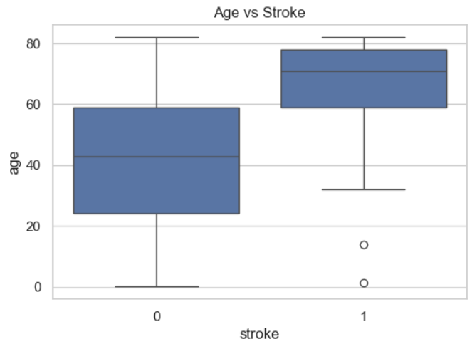
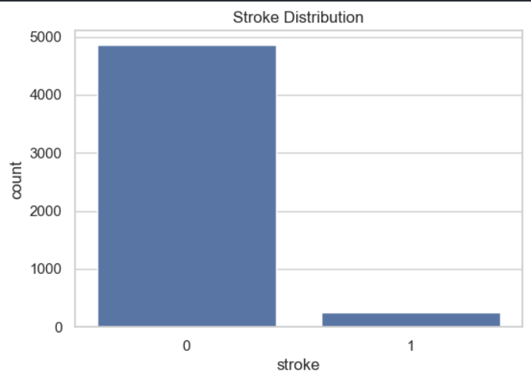
Figure 1:Age Distribution Comparison Between Stroke and Non-Stroke Patients
Figure 2:Distribution of Stroke and Non-Stroke Cases in the Dataset

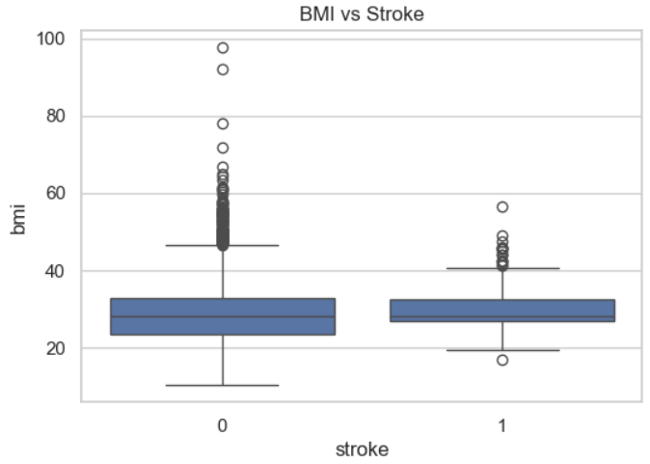
Figure 3:BMI Distribution for Stroke and Non-Stroke Cases

Class Balancing
SMOTE is applied to oversample the minority class (stroke cases) to ensure balanced class distribution and improve model learning.

Normalization
StandardScaler is used to normalize numerical features such as age, BMI, and average glucose level.

Train-Test Split
The dataset is split into training and testing sets using an 80:20 ratio.

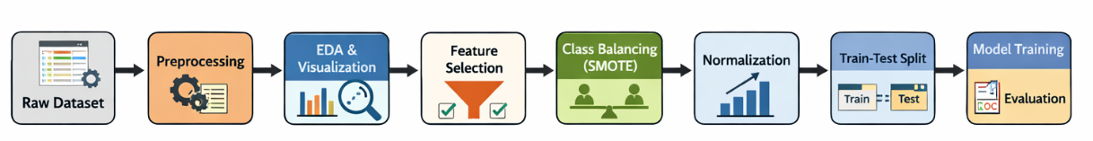
Framework Diagram Steps

ALGORITHMS USED

Logistic Regression
Selected as a baseline model due to its simplicity, interpretability, and effectiveness in binary classification problems.

Random Forest
Chosen as the primary model because it reduces overfitting, handles mixed data types, and provides better performance on imbalanced datasets.

EXPERIMENTAL SETUP

Dataset Description
The experiments were conducted using a publicly available healthcare stroke dataset containing thousands of patient records. Each record represents an individual patient and includes multiple clinical and demographic features such as age, gender, body mass index (BMI), average glucose level, smoking status, work type, marital status, residence type, and medical history indicators. The target variable is a binary class label indicating whether the patient has experienced a stroke (1) or not (0). The dataset exhibits a significant class imbalance, with stroke cases being considerably fewer than non-stroke cases, which reflects real-world medical data distribution.

Dataset Link
The dataset used in this study is publicly available and widely used for academic research on stroke prediction:
- Healthcare Stroke Dataset (Kaggle):
https://www.kaggle.com/datasets/fedesoriano/stroke-prediction-dataset

Hardware Configuration
All experiments were performed on a standard personal computer, which demonstrates that the proposed approach does not require high-end or specialized hardware. The system was sufficient to handle data preprocessing, visualization, model training, and evaluation efficiently, highlighting the practicality and accessibility of the proposed machine learning pipeline for academic and real-world applications.

Software Environment
The implementation was carried out using the Python programming language, which is widely adopted in machine learning and data science research. The following libraries and frameworks were utilized:
- Pandas for data loading, manipulation, and preprocessing
- NumPy for numerical computations
- Scikit-learn for machine learning models, data splitting, scaling, and evaluation metrics
- Matplotlib and Seaborn for data visualization and exploratory data analysis
- Imbalanced-learn for handling class imbalance using the SMOTE technique
- Joblib for saving trained models and preprocessing objects
This software stack ensures reproducibility, robustness, and ease of experimentation.

Hyperparameter Configuration
Two supervised machine learning models were trained and evaluated in this study:
- Random Forest Classifier:
The Random Forest model was configured with 100 decision trees (estimators). This number of estimators provides a balance between model performance and computational efficiency. The Random Forest algorithm was selected due to its ability to reduce overfitting, handle non-linear relationships, and perform well on structured healthcare data.
- Logistic Regression:
Logistic Regression was used as a baseline classifier and was trained with a maximum of 1000 iterations to ensure proper convergence during optimization. This model provides interpretability and serves as a benchmark to compare the performance of the more complex ensemble model.
All hyperparameters were chosen based on commonly accepted practices in machine learning research and were sufficient to achieve stable and reliable performance.

PERFORMANCE EVALUATION METRICS
- Accuracy
- Precision
- Recall
- F1-Score
- Confusion Matrix
- ROC Curve and AUC Score
High recall is particularly important to minimize false negatives in stroke prediction.
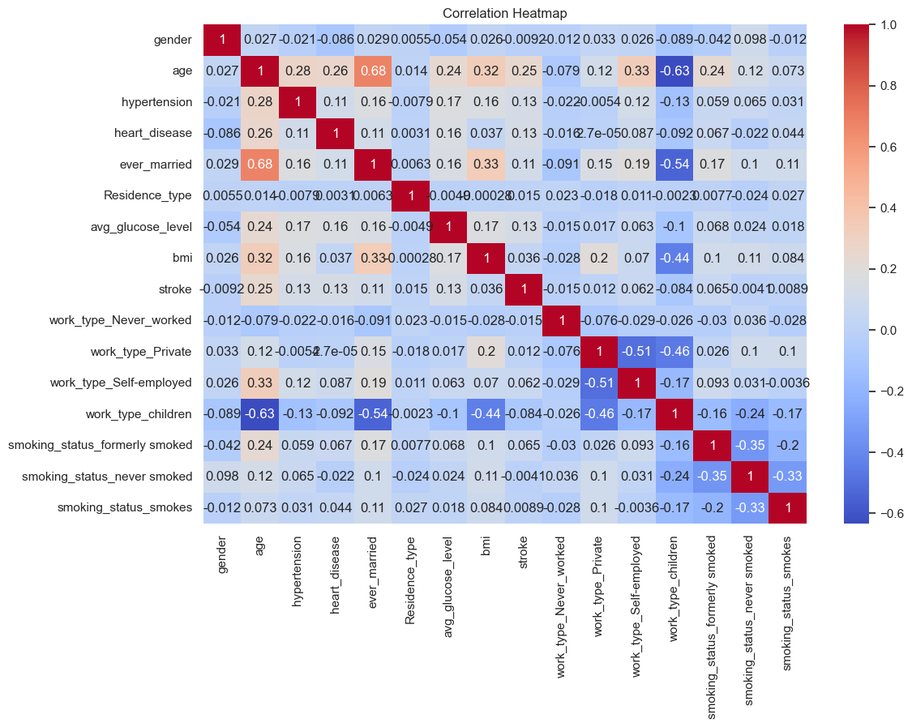
Figure 4:Correlation Heatmap of Healthcare Features

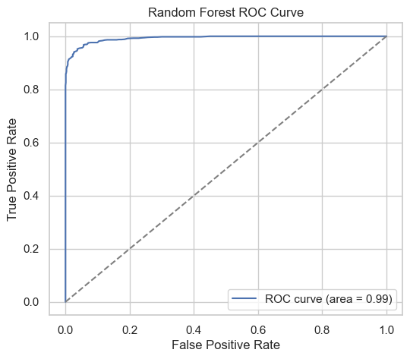

Figure 5:ROC Curve for Random Forest Model

RESULTS AND DISCUSSION
The Random Forest model achieved superior performance compared to Logistic Regression across all evaluation metrics. The use of SMOTE significantly improved recall and F1-score for stroke cases. ROC-AUC analysis confirmed strong discriminatory power. Errors mainly occurred in borderline cases with overlapping clinical features. The proposed system demonstrates strong potential for real-world healthcare applications.
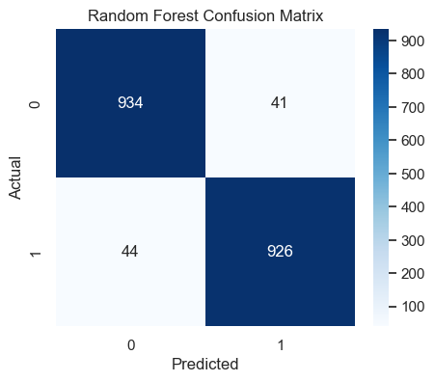
Figure 6:Confusion Matrix of Random Forest Classifier

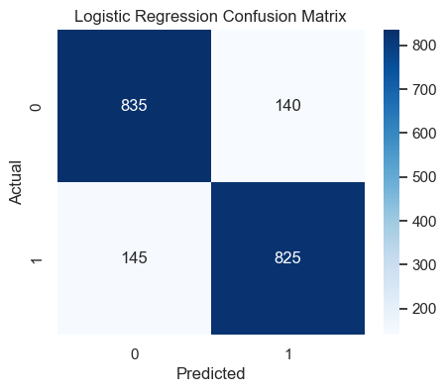
Figure 7:Confusion Matrix of Logistic Regression Model

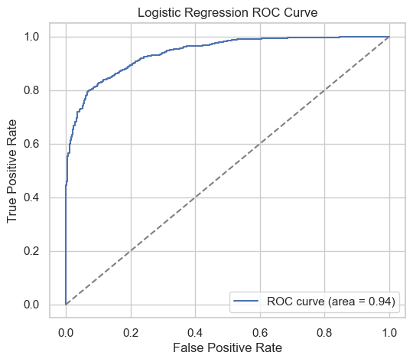
Figure 8:ROC Curve for Logistic Regression Model

CONCLUSION
This project presented a machine learning–based approach for predicting stroke risk using structured healthcare data. A complete predictive pipeline was developed, starting from data preprocessing and exploratory data analysis to feature encoding, normalization, and class imbalance handling using SMOTE. Two supervised learning models—Logistic Regression and Random Forest—were implemented and evaluated to perform binary classification. The results showed that the Random Forest model achieved superior performance across key evaluation metrics, making it more suitable for stroke prediction tasks compared to the baseline Logistic Regression model.
The study highlights the importance of addressing real-world challenges such as class imbalance and missing data in healthcare datasets. The use of SMOTE significantly improved the model’s ability to correctly identify stroke cases, which is critical in medical decision-making scenarios. Overall, the proposed system demonstrates the effectiveness of ensemble learning techniques for early stroke risk assessment. Future work may focus on incorporating additional clinical parameters, testing advanced machine learning or deep learning models, and deploying the system in real-time healthcare environments.

